ECPS204 Setup-Part B

CHENG-CHIH, LEE 29329351

Project Description (2 pts)
- The purpose of this part of the project is to prepare the environment for the canny application with the camera and further modify the canny application to process multiple images in a row. Profiling the canny is also included for evaluating the application performance.
- Finally, we want to encode the captured images into a video.

- Experimental Setup (4 pts)
- For this project, I set up a Git repository to exchange files between my RPi and laptop. Following the instructions, I get each step done and recorded.
- I had to use libcamera to do simple camera control since I’m using RPi 5 with newer SW.

- Results (6 pts)
- Step 1 & 2: Install OpenCV and understand the sample code
-OpenCV4 is successfully installed.
-Canny application is implemented and I captured one image of my keyboard as shown below.
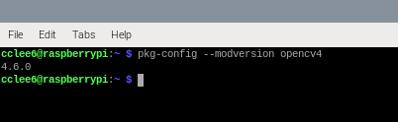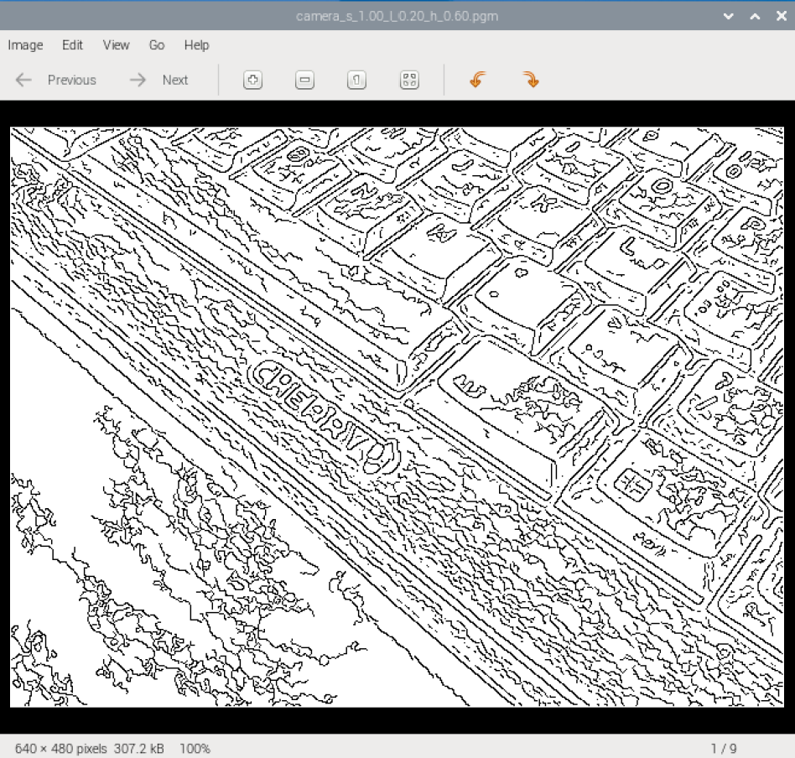
- There are three files included in this project, they are canny_util.c, canny util.h, and camera_canny.cpp.
canny_util.c and canny util.h are the algorithm source code and the header file; camera_canny.cpp is for utilizing the camera to capture images and canny algorithm to process them, including exporting the processed files.
-Quick overview of the sample code:
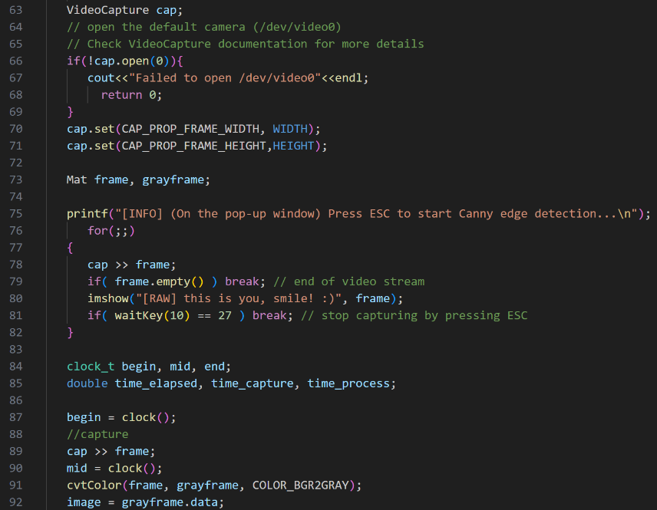
a.Declare VideoCapture cap
b.Open cap and check status
c.Setting width and height of frames
d.Declaring frame and grayframe
e.for loop to show camera images until “Enter” key is pressed
f.Convert captured frame to gray scale and push to canny for processing.

- Step 3: Implement your code for processing multiple images and save in numerical order
I modify the code to capture images in a roll for canny application. The period of the capturing is configurable with an added parameter input. The processing is designed to have a 100ms gap between each capture.
Parameters are now <image><sigma>/<tlow>/<thigh>/<length>, time with unit as 100ms.
Steps | Results | Comment
Parameter input  <image><sigma><tlow><thigh><length>  *Unit of <length> is 100ms |  | Last param set as 50 for a 5000ms capturing
Application running | 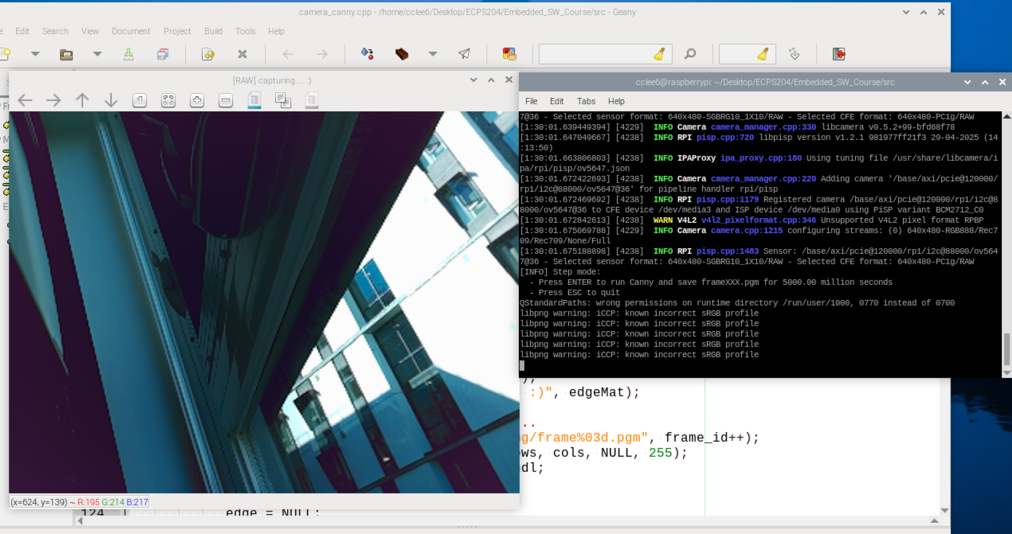 | Application initialized and showing camera views
Press “Enter” to start capturing | 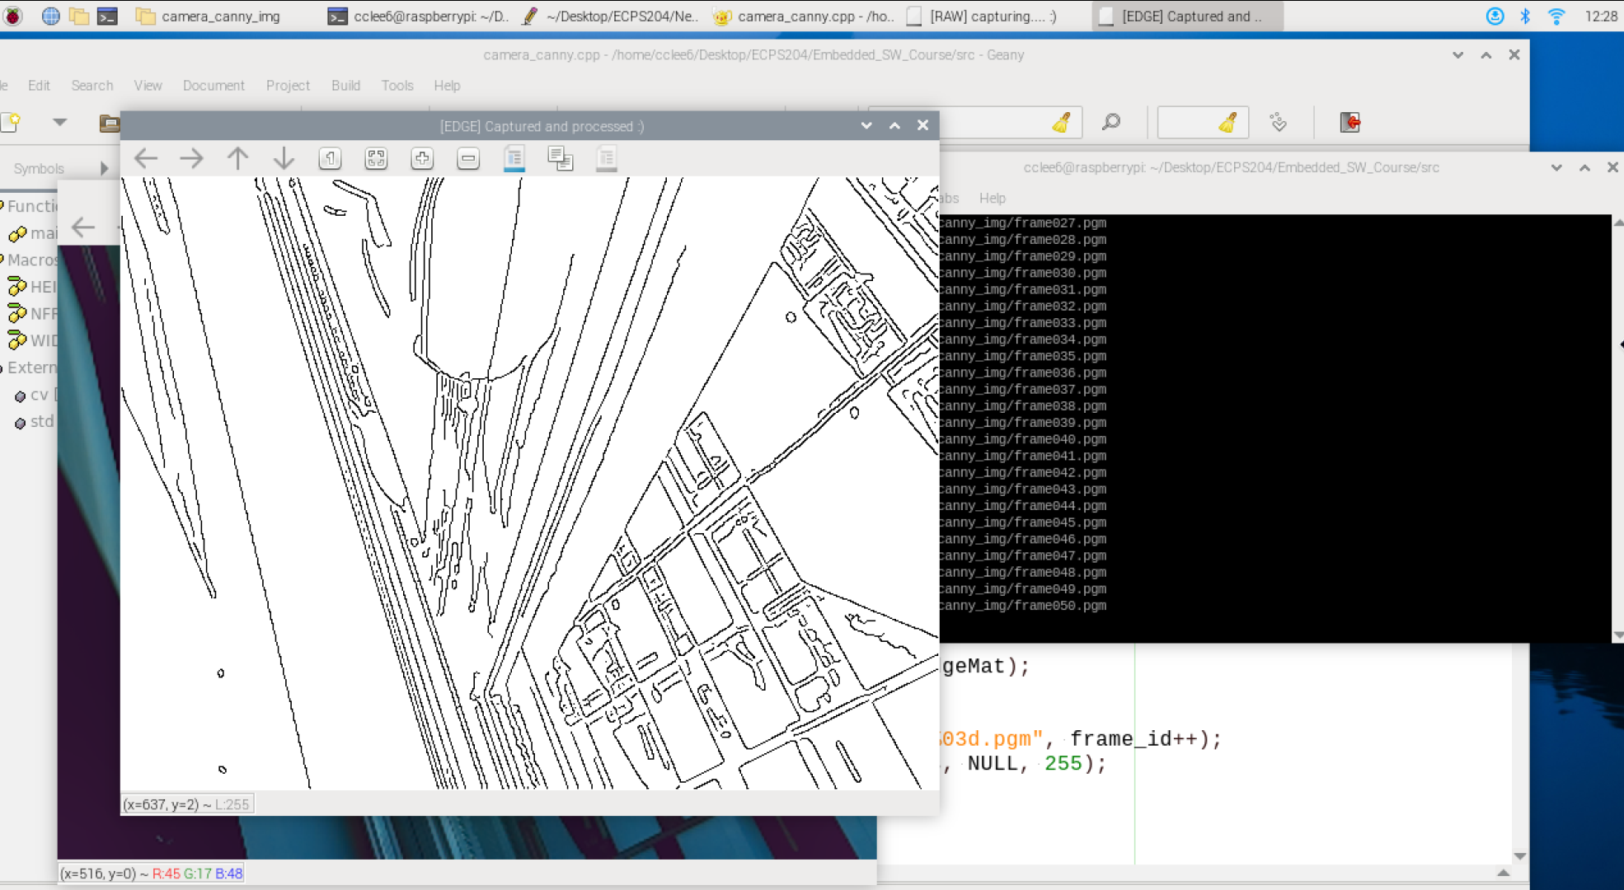 | 50 frames are taken. 100ms gap for each fame.
Press “ESC” to break capturing | 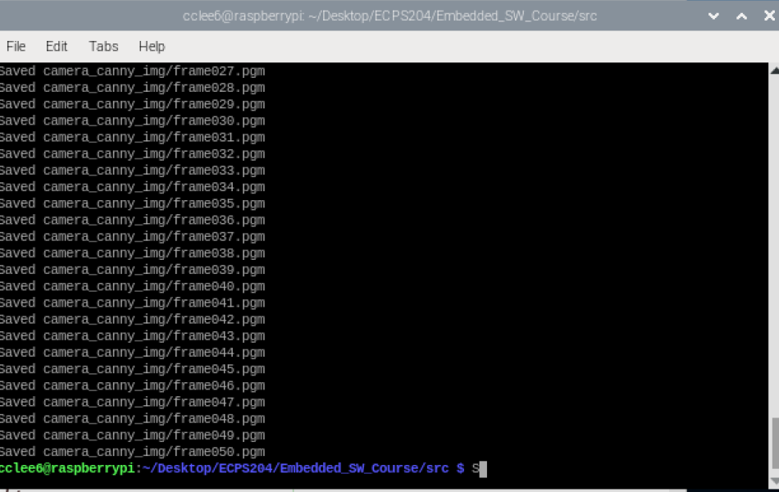 | Capturing done.
Files exported to intended directory | 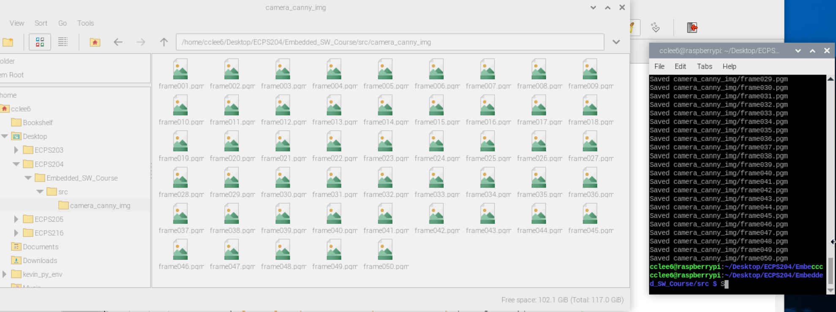 | All the files are now saved in the intended folder.

- Step 4: Profiling the performance

- Step 5: Encode your frames into a video

- Problems and Discussion (6 pts)
- First, I was a little stuck by the camera library but that was an easy fix by switching to libcamera.
- Setting up the repository took me a little bit of time since I would need the passkey to operate git access on my RPi.
- Other parts are fine and clear.
- Conclusion (2 pts)
- After setting up the environment and RPi, the camera functioned as expected.
- After testing canny with different parameters, I came up with the conclusion that the <sigma> defines the magnitude of smoothing; <tlow> defines the lower threshold to remove an edge; <thigh> defines the higher threshold to keep an edge.

